# Trigger

CREATE TABLE students

(student_id VARCHAR2(10),

student_name VARCHAR2(30),

college_major VARCHAR2(15),

status VARCHAR2(15));

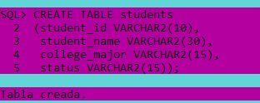

CREATE TABLE TEMP (AMOUNT NUMBER);

INSERT INTO TEMP VALUES (0.12345);

INSERT INTO TEMP VALUES (12345.1209);

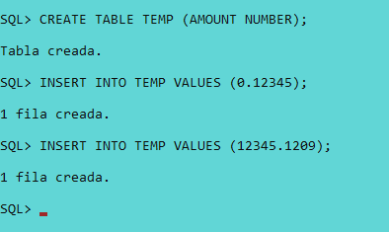

ALTER SESSION SET NLS_DATE_FORMAT='DD-MON-YYYYhh24:MI:SS';

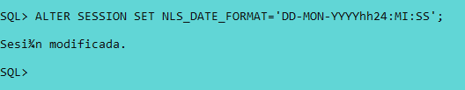

CREATE TABLE student_writting_samples

(student_id VARCHAR2(10),

writing_sample CLOB));

CREATE TABLE student_transcripts

(student_id VARCHAR2(10),

transcript SYS.XMLTYPE);

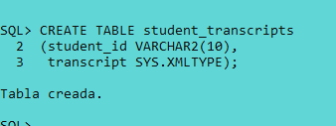

INSERT INTO student_transcripts

(student_id, transcript)

VALUES ('A101',

sys.XMLTYPE.createXML('<STUDENT_TRANSCRIPT>'

||'<CLASS>'

||'<COURSE>Math 101</COURSE>'

||'<GRADE>A</GRADE>'

||'</CLASS>'

||'<CLASS>'

||'<COURSE>English 102</COURSE>'

||'<GRADE>A</GRADE>'

||'</CLASS>'

||'</STUDENT_TRANSCRIPT>'));

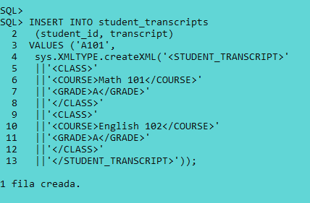

set long 10000

SELECT

student_id,

p.transcript.getClobVal()

FROM

student_transcripts p;

